Technology Architecture
Baseline Document

Project: | 311 Re-architecture



Version 1.0 Revised 02/22 /2010

Prepared by:
Name | Ricardo Arenas
Department | Enterprise Technology Service Department
Date | 02/22/2010

REVISION HISTORY

Date | Version | Description | Author
02-22-2009 | 1.0 | Created | Ricardo Arenas
Table of Content
1. Introduction 4
1.1. Overview 4
1.2. Reference materials 4
2. APPLICATION COMPONENTS FOR CURRENT 311 5
2.1. Motorola CSR 5
2.2 AVAYA 6
2.3 ETSD Application Components 9
2.4 GIC Application Components 10
3. TECHNOLOGY COMPONENTS 12
3.1. INFRASTRUCTURE 12
3.2. MIDDLE WARE COMPONENTS 12
3.1.1 WebSphere Application Server 12
3.1.2 WebSphere Voice Suite 12
3.1.3 WebSphere Message Broker 15
3.1.4 WebSphere Commerce Suite 15
3.1.5 WebSphere Portal Server 15
3.1.6 WebSphere Process Server 17
4. DATABASES 17
5. OTHER INFRASTRUCTURE COMPONENTS 18
6. SYSTEM - TECHNOLOGY MATRIX 18

Table of Figures
Figure 1- Motorola Contact Center Connectivity to Avaya 7
Figure 2- Avaya Interaction Center Manager Arrangement 8
Figure 3 - Miami-Dade AE Services Configuration 9
Figure 4 - 311 Current Implementation 11
Figure 5 - Enterprise IVR Infrastructure 14
Figure 6 - ETSD eNet Portal 16

Introduction

Overview
The purpose of this document is to provide a brief description of the existing Technology Architecture currently supporting the 311 system implementation. This document adheres to the TOGAF guidelines and constitutes the Baseline Technology document for the 311 Re-architecture project. Part of this document is some of the technology components supported by ETSD which can be used for the implementation of the new 311 CiRM System.
Some technology components in the current 311 Implementation are in a critical path given that they are already out of support or they will soon be going out support by its respective vendors. These componets are Avaya MAPD cards, Avaya IC and Oracle database version 9.2.0.8.

Reference materials
- Enterprise IVR-Overview.doc
- Motorola Toolkit Users Guide.doc
- IC Arrangement.vsd
- MiamiDade_AES v09202007.vsd

APPLICATION COMPONENTS FOR CURRENT 311

Motorola CSR
Motorola CSR is a set of applications designed to manage Service Requests placed by citizens who contact Miami Dade County by phone, the web, and email or in person. Motorola CSR is formed by several applications like the Customer Service Request (CSR), Contact Center, Web Intake and the Toolkit.
CSR
CSR is a Customer Request Management application in charge of managing requests placed by citizens regarding to different types of services offered by 311. CSR is the main request intake application used by 311.
Version: 3.10.3
Type: Oracle forms
Back end database: V310PROD – Oracle 9.2.0.8 (see databases section)

CONTACT CENTER
Contact Center is an application that enables creation of service requests in CSR and knowledge base searches; it aligns contact channels with service delivery processes to efficiently respond to citizens. It’s running on the Call Takers desktops and it’s fully integrated with the Avaya Computerize Telephony Integration (CTI).
Version: 2.0
Type: Java based application

TOOLKIT
The Motorola Toolkit is a set of APIs which allows external applications to interface with CSR back end database. This is a java stand alone program running as a background job on AIX server S0140772. The Toolkit interfaces directly to Animal Services Department System and Elections database to provide query capabilities in CSR for Animal Services and Elections. It uses an Oracle database, ICSRW, to move service requests transactions in and out CSR database. For more information about the Toolkit see the Motorola Toolkit Users Guide.doc document.
CSR MOBILE
CSR Mobile is a light weight version of CSR that runs on laptops. It allows field workers to wirelessly retrieve assigned customer service request data from CSR database in order to begin work on these requests immediately in the field. It also allows entering service requests on the field which are transmitted to CSR wirelessly via a Sync Server. 311 Laptops are using ATT air cards to provide wireless connectivity to the Sync server.
WEB INTAKE
Web Intake is a web application that allows individuals to submit service requests and to query status of service request via the internet. This application is not currently in use by 311 for two reasons, it didn’t pass the security standards of ETSD and it does not provide the business functionalities required by 311.
PHONE BOOK
Phone Book is a web application that allows individuals to search for phone numbers of MDC users registered in CSR. This application is not currently in use by 311 for two reasons, it didn’t pass the security standards of ETSD and it does not provide the business functionalities required by 311.

Motorola CSR Applications
Application Name | Status
CSR | Actively used by 311 Call Center
Contact Center | Actively used by 311 Call Center
CSR Mobile | Passively used by 311- Animal Service field staff
Toolkit | Actively used to interface to MDC legacy applications
Phone Book | Not currently in use (uninstalled)
Web Intake | Not currently in use (uninstalled)

AVAYA

AVAYA INTERACTION CENTER (ver. 6.1.3)
The Avaya Interaction Center software provides enterprise-class control of contact-center communications across multiple channels: voice, video, email, Web chat, and IP telephony. It provides a software bridge between the Motorola Contact Center Soft Phone application and the Avaya PBX switch. Avaya IC is installed on two Windows 2000 servers, S0320064 and S0320065, each handling 50 licenses. They require an Oracle database to host configuration and licensing information.
Critical Component:
The Avaya IC ver 6.1.3 is out support and ETSD is unable to upgrade to their current version release due to the incompatibility with the Motorola Contact Center ver 2.0. Upgrading Avaya IC includes getting a new Avaya Soft Phone and the Motorola Contact Center is hard coded to interface with the Avaya Soft Phone API that comes with IC ver 6.1.3.

AVAYA AGENT – SOFT PHONE
The Avaya Agent is a client application that provides soft phone capabilities on the desktop. The Avaya agent currently runs as a background job in the call takers desktops and is the Motorola Contact Center application the one providing the soft phone capabilities to the call takers. Motorola Contact Center is programmed to interface directly with the Avaya Agent API to provide the soft phone features and to communicate to the Avaya PBX.
AVAYA PBX (S8700)
The Avaya PBX model S8700 is located at MDC Fire Headquarters and it’s shared between 311 and the Fire Department. The PBX contains two plugged in Multi-Application Platform on Definity (MAPD) cards. The Avaya IC servers S0320064 and S0320065 connect to these cards. See Figure 1 -Motorola Contact Center Connectivity to Avaya.
Avaya is no longer providing support for the MAPD cards. The Avaya Application Enablement Services (AES) is the technology replacing the MAPD cards. ETSD already installed the AES in a test environment connecting to our test IC servers. To promote the AES solution from test to our production environment an agreement on the licensing has to be reached between Avaya and MDC. See Figure 2 - Avaya Interaction Center Manager Arrangement and Figure 3 - Miami-Dade AE Services Configuration.

Critical Component:
The Avaya MAPD cards are currently out of support.

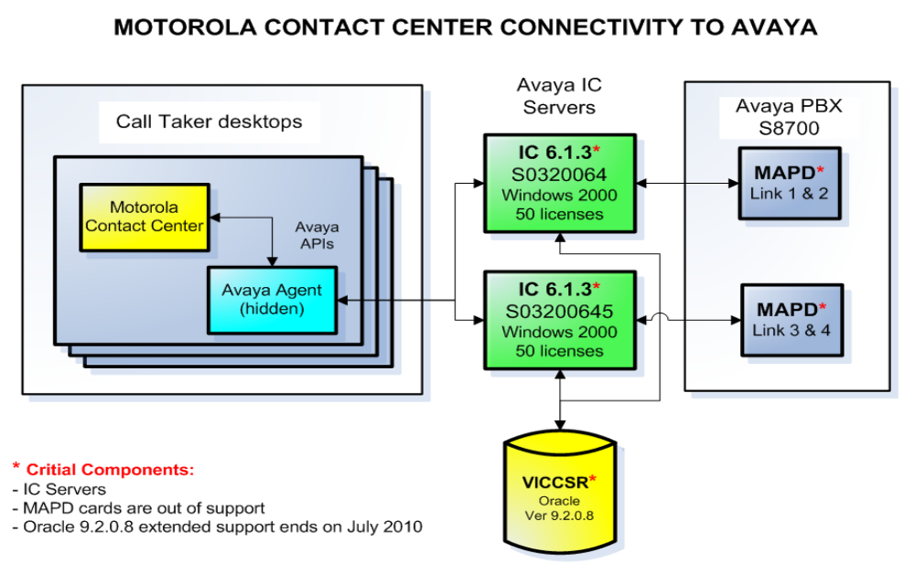
Figure 1- Motorola Contact Center Connectivity to Avaya
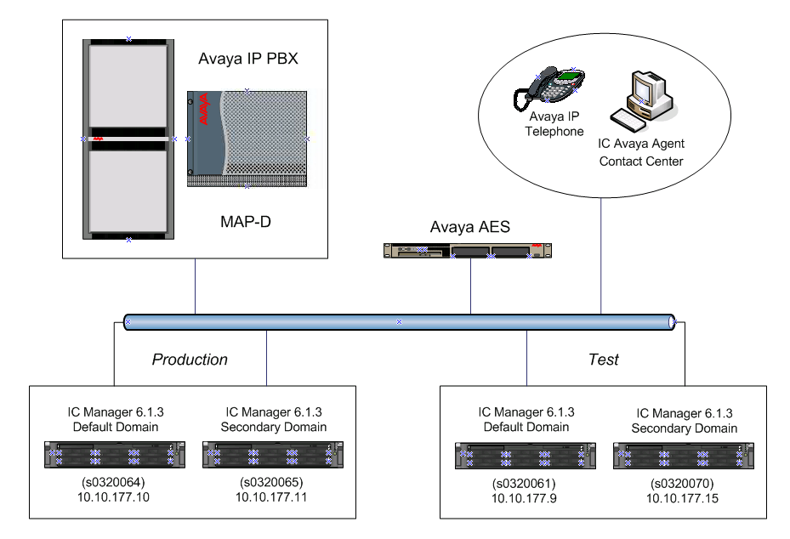
Figure 2- Avaya Interaction Center Manager Arrangement

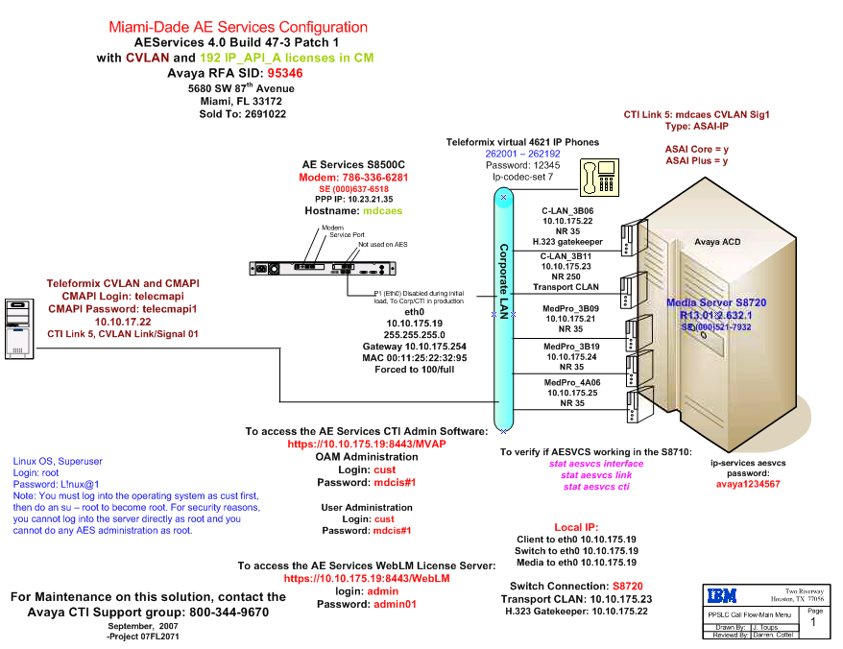
Figure 3 - Miami-Dade AE Services Configuration

ETSD Application Components

BLUE BOOK
Blue Book web application is a phone directory of the Miami Dade County employees. It is for internal use only accessible though eNet.miamidade.gov. 311 call taker specialists access Phone Book directory to provide citizens information about employees and departments phone numbers.
SERVICE STAT
ServiceStat is a web application designed to track information on citizen requests for service received through 311, ServiceDirect and other County departments. It retrieves information from the CSR Real Time Reporting database (CSRRPPD) to provide counts and statistic information on Service Requests based on service type, geo layer, time frame, etc. It also integrates to ETSD GIS to goe code service request information.
GIS (Data Refresh)
Geographical Information from ETSD GIS databases is loaded on a weekly basis to CSR GIS tables for address validation.
MDCEAI
MDCEAI, Miami Dade County Enterprise Application Integration is a web based java application that allows integration between CSR and five MDC legacy systems. MDCEAI interacts with the Motorola Toolkit to send/retrieve data to/from CSR and also to connect to legacy systems like Team Metro Case Management System (CMS), Public Works System (PWS), City of Miami (COM), Waste Collection System (WCS) and Property Tax (PTX). The integration segment between MDCEAI and the legacy systems was a custom development between ETSD and the departments. It uses an Oracle database as a staging area to parse and process service transactions for each department.
KBMS
KBMS, Knowledge Base Management system is a custom made web application in charge of loading knowledge base information into CSR database. It provides the ability to select and upload documents to a shared folder. The Uri defining the location of the document as well as some key words regarding its content are saved in the CSR database. This information is later indexed and accessed by Contact Center to provide call specialists all the information related to a specific topic, service request, department or event. KBMS implementation includes a MSSQL 2005 database to store the reference to the document, summary, keywords, etc; this information is transferred on a regular basis to CSR database through a MSSQL job.

GIC Application Components

SERVICE DIRECT
Service Direct is a java web based application that allows citizens to enter service requests via our MD County portal. It contains the same business logic of few service requests as they are configured in the Motorola CSR. It uses an Oracle database as a staging area to verify and authenticate the information entered by the citizen and then is transferred to CSR via MQSeries -> Service Direct monitor -> Motorola Toolkit.
SERVICE DIRECT MONITOR
Service Direct Monitor is a java application in charge of moving service request information between CSR and Service Direct database. On the CSR side, Service Direct Monitor interfaces with the Motorola Toolkit sending/retrieving service request transactions to/from CSR, and on the Service Direct side it interfaces with IBM Message Broker to send/retrieve service request information to/from Service Direct database.
PKBI - PORTAL KNOWLEDGE BASE INTEGRATION
PKBI is a custom made portal application in charge of managing knowledge base information. The intention is to replace KBMS with PKBI and now PKBI is progressily being used more actively than KBMS. PKBI is still on its first phases of development, its still evolving to provide better Enterprise Integration and to become an extension of a content management tool for the GIC portal.
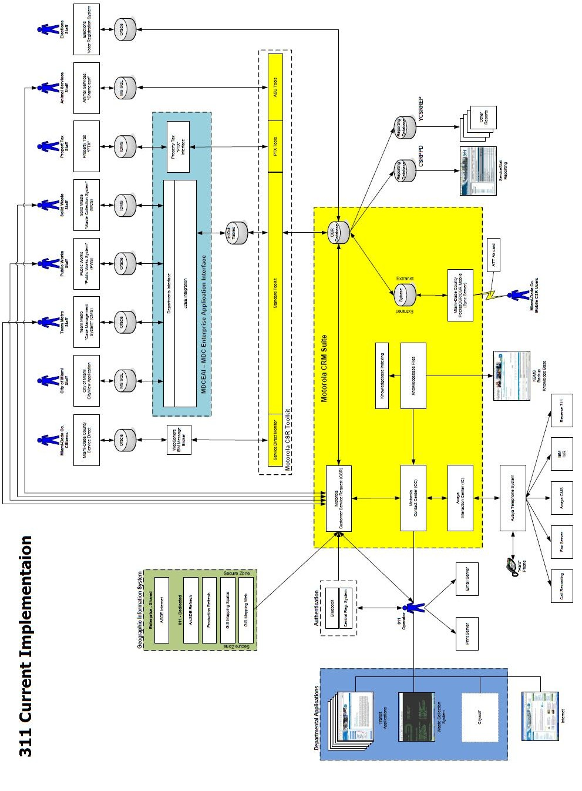
Figure 4 - 311 Current Implementation

TECHNOLOGY COMPONENTS

INFRASTRUCTURE
The primary operating systems MDC ETSD supports for the application and database servers are Windows and IBM AIX. ETSD infrastructure support group adheres to vendor specifications to keep all operating systems up the up to the current version update and technology levels. ETSD also maintains and support IBM Mainframes, which are not part of the scope of this document.

MIDDLE WARE COMPONENTS
All components of the WebSphere suite at ETSD are up to date and some of them are being upgraded to the latest version. ETSD is planning to keep providing support to the WebSphere Suite components.

WebSphere Application Server
WebSphere Application Server V6.1 is the premier open-standards Java™ 5 Standard Edition (J5SE), Java 2 Enterprise Edition (J2EE) 1.4, and Web services-based application server. It helps you deploy and manage applications ranging from simple Web sites to powerful on demand solutions. WebSphere Application Server offers a rich application deployment environment with a complete set of application services, including capabilities for transaction management, security, clustering, performance, availability, connectivity, and scalability.
ETSD Version: 6.1
Hosted on: AIX 5.3

WebSphere Voice Suite
The WebSphere Voice software family ranges from transcription and voice response technology to message center services, voice access to e-business applications, and more.
ETSD implemented an Enterprise Interactive Voice Response infrastructure (IVR) using WebSphere Voice Server, WebSphere Voice Response and VSIFax. VSIFax is not part of the WebSphere Voice family but it complements the IVR solution to provide faxing capabilities, see EnterpriseIVR-Overview.doc document for more information about ETSD Enterprise IVR. Figure 2 – Enterprise IVR Infrastructure shows the distribution of the IVR components.
WebSphere Voice Server:
WVS is software for developing and deploying conversational e-business solutions.
ETSD Version: 4.2.3
Hosted on: AIX 5.3

WebSphere Voice Response
WVR complements WebSphere Voice Server making it possible to create integrated Web and telephone self-service access to data and processes. Supports speech recognition technologies, enables Java™ and VoiceXML service and includes VoiceXML and Call Control XML industry-standard programming environments.
ETSD Version: 5.1.3
Hosted on: AIX 5.3

VSIFax
VSI-FAX is a comprehensive, multi-platform fax solution that enables faxing of any document from any application running on Linux, UNIX, or Windows Server 2003/2008.
ETSD Version: 6.0

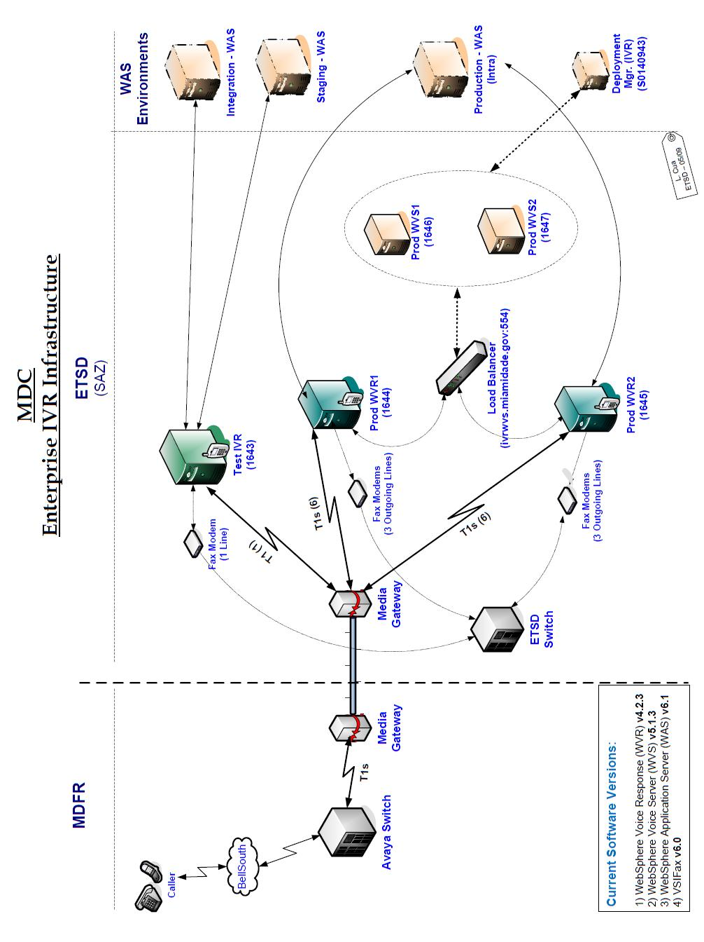
Figure 5 - Enterprise IVR Infrastructure

WebSphere Message Broker
WebSphere Message Broker delivers an advanced ESB (Enterprise Service Bus) that provides connectivity and universal data transformation for both standard and non-standards-based applications and services to power your SOA.
ETSD Version: 6.0
Hosted on: AIX 5.3
Maintenance Level: 9

WebSphere Commerce Suite
IBM WebSphere Commerce is a software platform framework for e-commerce, including marketing, sales, customer and order processing functionality in a tailor able, integrated package. It is a single, unified platform which offers the ability to do business directly with consumers (B2C), with businesses (B2B), indirectly through channel partners (indirect business models), or all of these simultaneously. WebSphere Commerce is a customizable, scalable and high availability solution built on the Java - Java EE platform using open standards, such as XML, and Web services.
WebSphere Commerce Suite is not being used in the current 311 implementation but it’s a very good solution to incorporate payment options to the new 311 implementation.
ETSD Version: WebSphere Commerce Server v5.6.1.2
Hosted on: AIX

WebSphere Portal Server
WebSphere Portal is a set of software tools to build and manage web portals. WebSphere Portal software provides a composite application or business mash up framework and the advanced tooling needed to build flexible, SOA-based solutions, as well as the unmatched scalability required by any size organization. See Figure 3 - ETSD eNet Portal.
ETSD Version: 6.1.5
Hosted on: AIX 6.1

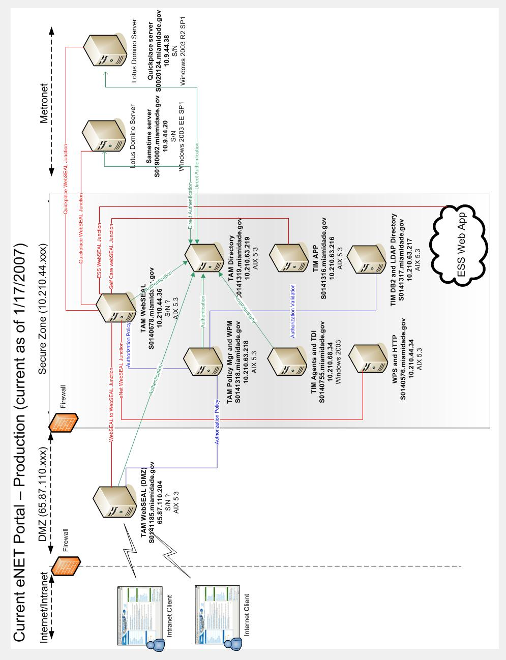
Figure 6 - ETSD eNet Portal

WebSphere Process Server
WebSphere Process Server allows developing and executing standards-based, component-based business integration applications in a Service Oriented Architecture. Because it is based on J2EE 1.4 infrastructure and platform services provided by WebSphere Application Server V6, WebSphere Process Server includes capabilities such as business process automation.
WebSphere Process Server is not being used in the current 311 implementation but it’s a very solution to build the required system integrations for the new 311 implementation.

DATABASES

ETSD maintains and support Oracle and MSSQL databases as their primary option for Enterprise repositories. ETSD database support group adheres to vendor specifications to keep databases up to the current version release as well as to perform backup plans to production and test environments.
The following is a list of Databases used by ETSD on the current 311 Implementation
Database Name | Application Component | Type | Ver.
V310PROD | CSR | Oracle | 9.2.0.8
CSRPPD | CSR Reporting (Streams) | Oracle | 9.2.0.8
YCSRREP | CSR Reporting | Oracle | 9.2.0.8
ICSRW | Motorola Toolkit/MDCEAI | Oracle | 9.2.0.8*
VICCSR | Avaya Interaction Center | Oracle | 9.2.0.8
ELECT311P | Elections | Oracle | 10.2.0.4
BSDEB | GIS Refresh for CSR | Oracle | 9.2.0.4
SQLSRVPRD1 | KBMS | MSSQL | 2005

Critical Component:
Oracle version 9.2.0.8 is coming out support by July 2010. ETSD cannot upgrade the majority of the databases described in the table above because of the dependency with the Vendor Motorola.
*ICSRW is the only database scheduled to be upgraded to Oracle 10.2.0.4 in the near future.

OTHER INFRASTRUCTURE COMPONENTS

Hardware, such as wires, fiber, routers, hubs, backups and other computers or programmable devices are part of the ETSD infrastructure components but are not relevenat to this phase of the Project.

SYSTEM - TECHNOLOGY MATRIX

Application Component | Deployment Unit | Technology Component
Motorola
CSR, Contact Center | Oracle Forms, Java application | Application Server Cluster S0320104, S0320105, S0320106, S0320107
Toolkit | Java application | Application Server S0140772
CSR Mobile | Java Application | Laptops/Att Air card
CC Index Server | Oracle Job | S0320103
V310PROD, VICCSR, CSRPPD, YCSRREP, VICCSR | Oracle Database | Database Server cluster S0140718, S0140677
Avaya PBX and MAPD cards | Avaya Software/Hardware | Phone Switch
Avaya IC Servers | Avaya Software | Application Server cluster S0320064, S0320065
Avaya Soft Phone | Avaya Software | Windows PCs
ETSD
Blue Book, Service Stat and KBMS | .Net application | Application Server cluster Windows IIS
GIS Mapping servers | Arc GIS | Application Server cluster S0320086, S0320085, S0320001, S0320002
MDCEAI | J2EE application | WebSphere Aplication Server S0140772, S0140785
SQLSRVPRD1 | MMSQL database | Database Server cluster
GIC
Service Direct Monitor | Java application | Application Server S0140772
Service Direct queue | MQ Series queue | WebSphere Message Broker server
Service Direct application and PKBI | Portal application | WebSphere Portal Server

